**Simple COVID 19 Tracker**

**by Soumyadeep Dey**



* We have Susceptible (S), Infected (I), Recovered (R)
* And two things can happen
* Transmission: An I infects an S, who will then become another I.
* Recovery: An I can recover and become an R

Lets say R is 10% per day, so if a certain day has 1000 Infected then 100 will recover every day ideally.

Let’s say every time a S meets an I the probability of getting infected is p.

Now every S and every I do not meet ,so we need to have a probability of them meeting which is c.

* So we have a average of c*S*I contacts per day.
* So on average we should see c*p*S*I infections a day.
* Our b is b = c*p
* So we can also say b*S*I are the average infections per day.

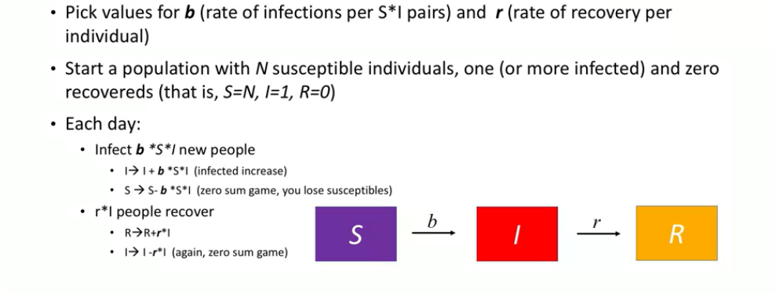

If we incorporate vaccination in the picture

